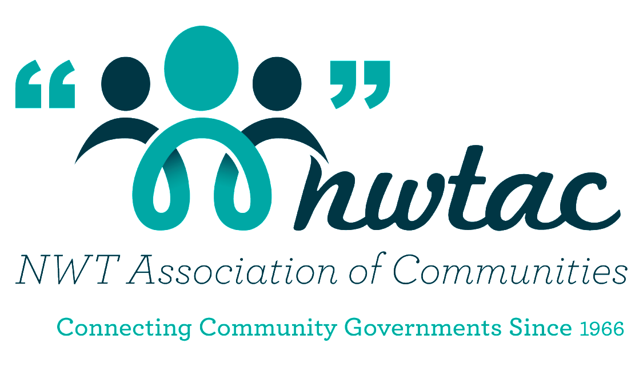

NWTAC
Healthy Communities

Sponsored by:

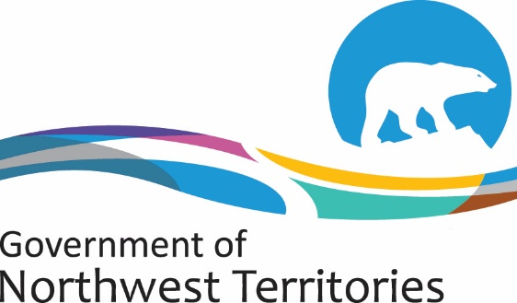

Health and Social Services

Award Description

The aim of the Healthy Community Award is to celebrate an NWT community that encourages and supports residents in adopting healthy lifestyle choices by providing programs promoting physical activities, nutrition and social connections that foster positive mental health. The award is sponsored by the GNWT Department of Health and social services and the community who wins this award receives $5000.00 to go towards a healthy initiative in your community.

All 33 communities of the NWT are eligible to enter the Healthy Communities Award. All your community has to demonstrate is you as a community are encouraging residents of all ages to achieve and maintain their best possible health. Healthy communities such as yours, support your residents in adopting a healthier lifestyle by providing access to physical activities, nutritious foods and social connections that foster mental health. Social, environment and economic factors are important determinants of human health and are interrelated.

Some of the qualities of a healthy community include
- Adequate access to healthy food choices, water, shelter
- Opportunities to learn and develop skills for living healthier
- Mental Wellness – help people realize their own abilities and let them learn how to cope with the stress of everyday life
- Drop the pop-raises awareness of the negative impacts of sugary beverages and encourages children to make healthy beverage choices.
- What it means to your health to be tobacco free

Communities that support healthy living make it easier for all residents regardless of age or ability to make healthy choices every day. Send in your application and tell us what your community is doing to promote a healthy community!

Complete the Nomination form and attach with that an explanation why your community should receive the Healthy Community Award. Tell us some amazing stories of how you as a community provide, promote and participate in making your community a healthy place to live.

Deadline for Nominations: February 19, 2021
Community Nomination Form

NOMINEE INFORMATION

Community Name: ______________________________________________________
Person nominating: _____________________________________________________
Address: ___________________________________________________________
___________________________________________ Postal Code: ______________
Work Phone: ___________________________ Fax: ___________________________
E-mail: _______________________________________________________________

Signature: _______________________________ Date: ___________________

Please let us know what your community has done to support healthy living and why you should receive the award. Please attach any additional information.

NWT Association of Communities
Tel: 867-445-9609 or 1-866-973-8359
Fax 867-873-3042
E-mail: yvonne@ntwac.com

